Ontario Amateur Wrestling Association
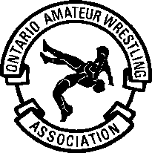
3 Concorde Gate, Toronto, Ontario M3C 3N7
Telephone: (416) 426-7274 Fax: (416) 426-7343
Web Site: http://www.oawa.ca E-mail: admin@oawa.ca

OAWA Pre-Event Inspection Procedures

Instructions to Head Official:

As you know, the event you have been assigned to has requested and granted Sanctioning by the OAWA. As part of this process, the event must go through a pre-event Risk Management Check.

Prior to the start of your event, you are to conduct a pre-event walk through of the Facility using the accompanying two-page checklist.

We suggest you review and familiarize yourself with these forms prior to departing for the event, since some checks can be done (eg. outside parking lot, etc.) as you enter the venue.

Ideally, this walk through should be completed with the event Convenor so that any identified issues can be cleared up immediately. However, if this is not possible due to the Convenor being otherwise occupied on pre-event work, then as Head Official you are to conduct the walk through yourself.

In either case, you are to bring any issues with respect to the Facility to the attention of the Convenor and these are to be cleared up immediately.

Important Note: As Head Official, you have the power designated from OAWA to shut down the event if any shortcoming is serious enough to warrant it. The event will remain shut down until the issue is addressed to your satisfaction.

Head Official and Convenor are to sign off on this report before the event begins.

Following the event:

- Send a copy of this report to the OAWA, along with:
    - A copy of the weigh-in list or weight verification list.
    - A complete copy of the event results.
    - A copy of the tournament draw/bracket sheets (if available).
Thank you for helping make Ontario Wrestling safer!

PRE-EVENT CHECKLIST:
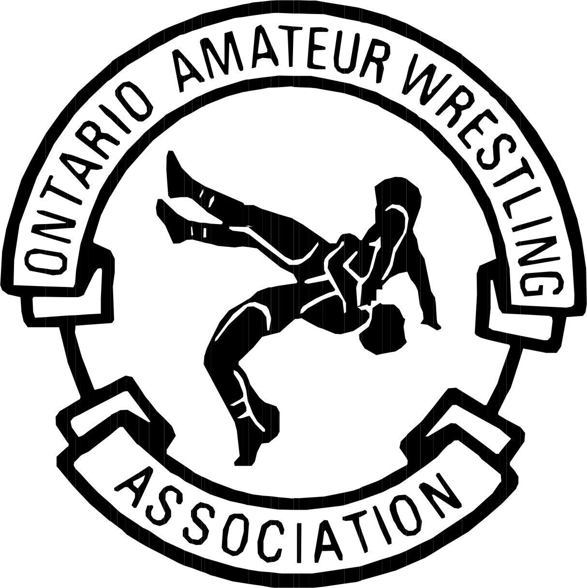Ontario Amateur Wrestling Association | RISK MANAGEMENT  CHECKLIST

Event Name: ______________________________________

Event Location: ______________________________________

Event Date: ____________________________

CONVENOR’S NAME: ____________________________

- Have physical inspections of facilities and equipment been completed?  Yes  No
Do you have a “Facility Walk Through Check Sheet” completed and filed for each?  Yes  No
- Have memberships been confirmed for all participants  Yes  No
- Has Event medical coverage been secured?  Yes  No
- List name of chief medical staff contact: ___________________________________
List medical staff and their background(s): ________________________________________________
- List name of chief facility person ___________________________________
- List name of Head Official ____________________________________
- List name of Event Registration staff ____________________________________
- Have injury Forms been provided to medical personnel?  Yes  No
- Does the chief medical staff person have access to phone for emergencies?  Yes  No
- Has Head Official confirmed that all officials are up-to-date OAWA members?  Yes  No
- Have all officials attended the pre-event clinic (if applicable)?  Yes  No
- Are mats and equipment in good condition, well secured, and properly installed?  Yes  No
- Have certificates of insurance been requested, if needed?  Yes  No

Other Comments (use reverse if necessary):

Signature of Event Convenor Date

Signature of Head Official Date

Ontario Amateur Wrestling Association | PRE-EVENT FACILITY  WALK THROUGH  CHECK SHEET

OUTSIDE:
- Does the parking lot surface and/or drop off area appear adequate, well lit, (if your activity will be
held after dark) and free of any dark areas and pot holes  Yes  No

INSIDE:

- Are there any obvious trip and fall hazards? (i.e. torn carpet, wet floor in restrooms
or elsewhere in the facility, poor lighting, non highlighted steps)  Yes  No
- Are all exits clear and well marked with lighted signs?  Yes  No
- Are the signs in working order?  Yes  No
- Are all required exit doors unlocked?  Yes  No
- Do all fire extinguishers have visible signage and current inspection tags?  Yes  No
- What is the visible general condition of any bleachers that may be used during your event?  Good  Fair  Poor
- Are the areas that your organization may require access to open, including first aid areas?  Yes  No
- Are areas that your organization will not require access to locked or otherwise secure?  Yes  No
- Are dressing rooms clean, well lit, and secure?  Yes  No
- Is the PA system in good working order?  Yes  No
- Have arrangements been made about how to close the facility
and who is responsible for this being established?  Yes  No
Have tear-down arrangements been made?  Yes  No
- Are restricted area, caution, etc. signs posted and visible if required?  Yes  No
- Has all event set-up equipment been stored and secured properly away?  Yes  No
- Indicate weight verification system used for event:
Random weight Checking ____

Full weigh-in _____
(check one to show which system used)
- MATS:

Are all competition surfaces/wrestling mats in good condition?  Yes  No

Have they been set up and secured properly?  Yes  No
Is there adequate protection space for competitors on each surface and to ensure safe distance to spectators?  Yes  No

- Have all of OAWA’s rules and regulations been reviewed and implemented?  Yes  No
- OTHER: Please list any other noteworthy comments (use reverse if necessary):
Signature of Event Convenor: __________________________________________ Date: ________________________

Signature of Head Official: ____________________________________________ Date: _________________________

